PROJECT DESIGN PHASE-II

DATA FLOW DIAGRAM & USER STORIES
Date: 21 September 2026
Team ID: SWTID-2026-3332
Project Name: AI FAQ Assistant API

1. DATA FLOW DIAGRAM

Level 0 Data Flow Diagram

The AI FAQ Assistant API receives requests from users through an application client or API testing client such as Postman. The requests are processed by the Node.js and Express.js backend and pass through authentication and authorization before reaching the appropriate business modules.

The system interacts with MongoDB for storing user information, FAQ records, categories, tags, AI-generated FAQs, and answer feedback. The system also interacts with the Google Gemini API for AI-powered FAQ generation and question answering. FAQ search is performed using relevant keywords across FAQ questions, answers, categories, and tags.

External Entities

● Admin

● Content Creator

● User

● API Client / Postman

Main Processes

● User Authentication

● User and Role Management

● FAQ Management

● Category and Tag Management

● AI FAQ Generation

● AI Question Answering

● FAQ Search

● Feedback Management

Data Stores
● Users
● FAQs
● Categories
● Tags
● AI Generated FAQs
● Answer Feedback

Simple Main Data Flow
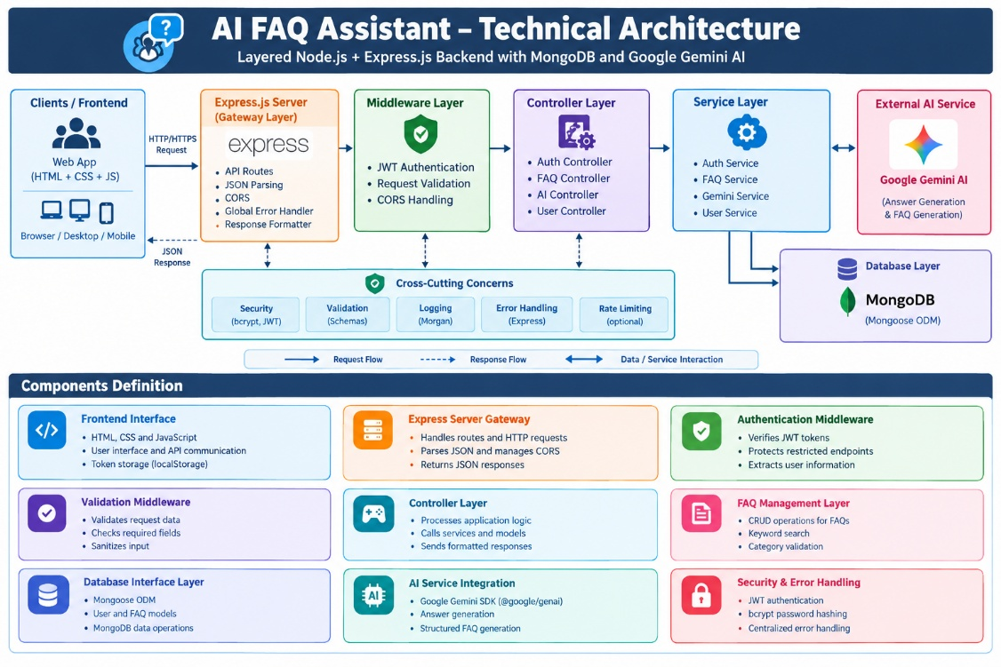

DFD (Industry Standard)

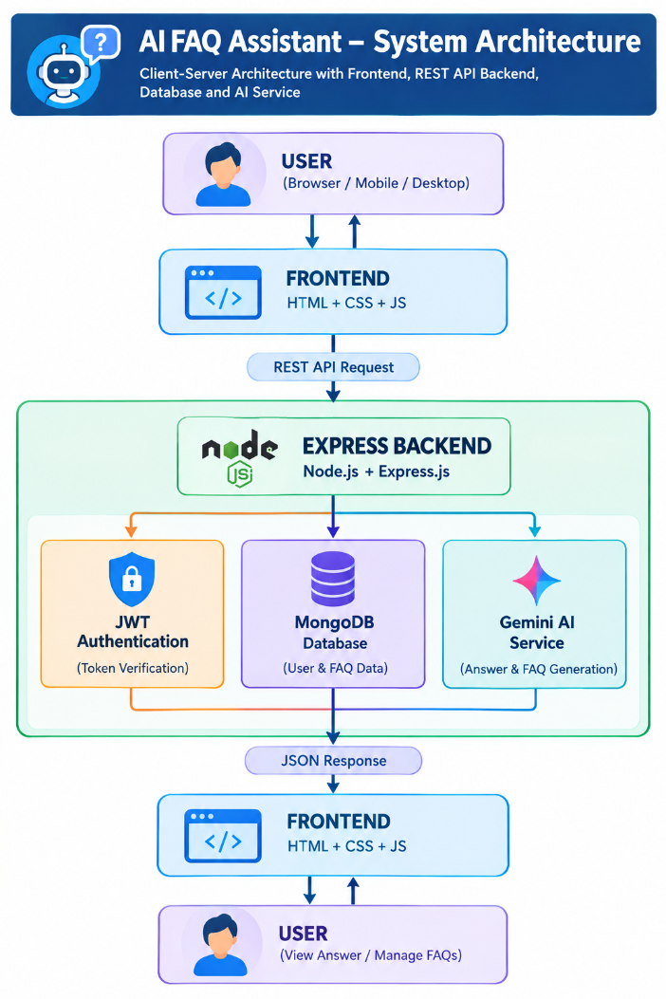

2.USER STORIES
The template requires the user type, functional requirement/epic, user story number, user story/task, acceptance criteria, priority, and release.

User Type | Functional Requirement (Epic) | User Story Number | User Story / Task | Acceptance Criteria | Priority | Release
Content Creator | Registration | USN-1 | As a content creator, I can register for the application using my name, email and password. | A new account is created successfully with the appropriate user role. | High | Sprint-1
All Users | Login | USN-2 | As a user, I can log into the application using my email and password. | Valid credentials generate a JWT token and allow authenticated access. | High | Sprint-1
Admin | User Management | USN-3 | As an administrator, I can view users and manage their roles. | Admin can view users and assign appropriate roles according to permissions. | High | Sprint-1
Content Creator | FAQ Management | USN-4 | As a content creator, I can create an FAQ with a question, answer, category and tags. | FAQ is created successfully with the provided question, answer, category and tags. | High | Sprint-2
Content Creator | FAQ Management | USN-5 | As a content creator, I can update and manage my own FAQs. | The content creator can update or delete FAQ records belonging to their account. | High | Sprint-2
Admin | FAQ Management | USN-6 | As an administrator, I can view and manage FAQ records. | Authorized administrator can view, update and delete FAQ records according to permissions. | High | Sprint-2
User | FAQ Access | USN-7 | As a user, I can view publicly available FAQs. | Public FAQs are returned successfully while private FAQs remain protected. | High | Sprint-2
Admin | Category Management | USN-8 | As an administrator, I can create and manage FAQ categories. | Authorized administrator can create, update and delete categories. | Medium | Sprint-2
Content Creator | Category & Tag Management | USN-9 | As a content creator, I can organize FAQs using categories and tags. | FAQs can be associated with valid categories and tags successfully. | Medium | Sprint-2
Content Creator | AI FAQ Generation | USN-10 | As a content creator, I can generate FAQ questions and answers using AI by entering a topic or prompt. | Google Gemini generates structured FAQ content containing a question, answer and topic suggestions. | Medium | Sprint-2
Admin | AI FAQ Generation | USN-11 | As an administrator, I can generate FAQ content using AI. | The system sends the prompt to Google Gemini and returns the generated FAQ content successfully. | High | Sprint-3
All Users | AI Question Answering | USN-12 | As a user, I can ask a question and receive an AI-generated answer. | The system returns a concise AI-generated answer. | High | Sprint-3
Content Creator | Save AI-Generated FAQ | USN-13 | As a content creator, I can save an AI-generated FAQ for future use. | The generated FAQ is stored successfully and can be accessed as a normal FAQ. | High | Sprint-3
Admin | Feedback Management | USN-14 | As an administrator, I can view feedback submitted by users. | Authorized administrators can retrieve feedback records associated with FAQ answers. | Medium | Sprint-3
All Users | Secure Access | USN-15 | As a user, I can access only the features permitted for my role. | Unauthorized operations return an appropriate access-denied response, while protected resources require valid authentication. | High | Sprint-3

